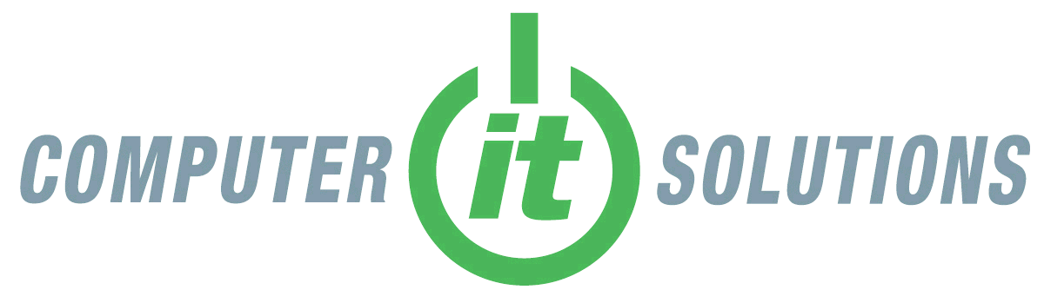

Computer In The Cloud
Service | Monthly Fee | Included In  Quote
In The Cloud Computer System | $70 | ☒
Shared Computer with 1 software application | $30 | ☐
Additional Profiles (first user free. Concurrent access allowed) | $10 | ☐
Anti-Virus Protection | included | ☒
Daily Backups | included | ☒
4 GB RAM | included | ☒
Additional 500 GB Storage | $10 | ☐
Additional 4GB RAM | $8 | ☐
User Profile | included | ☐
Windows 10 Operating System | $10 | ☒
Microsoft Office 2013 Professional (word, excel, powerpoint, onenote, outlook, publisher, access) | $9 | ☒
Quickbooks Pro 2016 | $12 | ☐
Quickbooks – other versions | Call or write | ☐
Exchange Mail Hosting | Call write info (click links) | ☐
Spam & Malware Filtering | Call write info (click links) | ☐
Seafile Data Duplication & Backup | Call write info (click links) | ☐
Setup & support | included | ☐
Daily Maintenance | included | ☐
Adobe Acrobat Xl | $10 | ☐
Adobe CS6 | Call or write | ☐
Other Software Programs | Call or write | ☐
TOTAL: $89

Additional; Quickbooks Enterprise 2016 $99 monthly for first 12 months only, rest free.

We’re changing the way small business does IT…

As a small business owner you work continually to improve your product or service, to attract new customers and keep them from turning to your competition. And why not, you’re the expert in your field, no one else is going to do it for you. Even so, your success depends on much more than just you. Your employees must be assigned and capable of performing strategic tasks, and your vendors too need support your interests and contribute to organizational goals such as product/service improvements and cost controls.
One area often overlooked for both financial savings and product/service improvements is IT. Business owners do what they think they know, use the latest technology to support and improve their networks. But that’s exactly the problem; they don’t know, technology is not their business, not their area of expertise. To best treat the human body we rely on doctors who complete at least four years of undergraduate school, four years of medical school and three to eight years of residency programs. The computer, which is only a fraction of your network’s IT infrastructure you rely on, uses technology that advances exponentially in complexity every year, and like the body decisions about it need be left in capable hands.
The solution is simple; do what you do best, hire the best for the rest. Tell us about your business, your product\services offered, your goals, successes and shortcomings. We’ll show you how to use the latest technology to make your operations run more efficiently and prevent you from spending money needlessly.

CLOUD COMPUTER HOSTING –VS- TRADITIONAL ON-SITE HOSTING
- No need for pricy computers. |  |  | Computers can cost several hundreds more each depending on performance requirements.
- No Server Required |  | As much as several thousand dollars additional cost.
- Lower software & licensing costs. |  |  | Will cost you hundreds to thousands more depending on the number of computers used.
- No computer hardware upgrades. | Will cost more than $100 more per PC based on case studies.
- Less frequent computer replacement. |  |  | Studies indicate small business users replace PC’s every 2-4 years.
- 90% reduction in IT supports costs. |  |  | Average cost for maintaining computer systems is $40 monthly per PC. For an office with 8 computers, that’s an annual cost of $3,840.00, or an added annual charge of $3,456.00 that need not be paid with Cloud Computer Hosting.
- Instant recovery from any crash. |  |  | Can be days down, with data loss and extra charges for data and computer system recovery.
- No slow computers. |  |  | Slow systems are common and result in lower productivity and additional IT costs for repair.
- Guaranteed backups of all data. |  |  | A backup program need be purchased, implemented and monitored. These are typically separate additional charges.
- No wasted – repeat purchases. |  |  | If inferior – wrong parts are purchased and used, additional purchase will be necessary.
- Accessibility from anywhere, anytime, cross platform. |  |  | Special provisions need be made for access and will not perform as well as on high powered cloud systems.
- Increased Collaboration – data access and sharing. |  |  | D Data is spread over multiple systems and cannot be as dependably or efficiently accessed.
- Improved Security. |  |  | - Data is on computers. If tampered with can be accessed, copied and removed. Does not exist on cloud accessed systems.
- More uptime – Less Downtime. |  |  | All small business owners are familiar with computer downtime as result of dependencies on local resources that perform poorly or fail altogether.
- Scalability | You will need to purchase new equipment and likely will trash older, antiquated hardware once purchased. No hardware to purchase with Cloud Computer Hosting.
Cloud Computer Hosting has all the benefits of existing companies plus Thousands of dollars in financial savings for not needing to purchase expensive computer system or contract monthly IT Support. Allocate the money for better office furniture or other expenses incurred when staring a business!

      - No need for pricy computers. The computers you purchase are only used for basic services such as a window to our powerful Cloud computers and local printing. They are very inexpensive.
- No Server Required. Traditional Servers cost thousands of dollars and are not needed as Cloud Computing has its own Servers for you.
- Lower software & licensing costs. No need to pay individual licensing and software fees for multiple computers.
- No computer hardware upgrades. You will no longer need to pay for larger hard drives or more RAM.
- Less Frequent computer replacement. A study by San Jose market research firm Techaisle estimated that in a 5-computer business with two old computers and three less than 3 years-old, the business could save $1500 in the first year by replacing the two older machines―a combination of reduced downtime and lower maintenance costs―enough to buy two new laptops and take the office to lunch. With Cloud Computing there would be no need for a replacement. Furthermore, as computers age their hardware is less likely to adequately accommodate the needs of newer programs. This is not a concern with Cloud Computing.
- 90% reduction in IT support costs. As consequence of not needing to address computer crashes, virus attacks, software problems and more, most IT support calls are eliminated. Let’s say for example that your office has 8 computers. That’s 8 machines that will need updates, are impacted by individual user habits, have various exposure to internet pages, opened email, shared data and more. Add to the mix differing hardware between the computers and it all adds up to a lot of time an IT Technician need spend on-site or remotely whenever a problem is reported. With Cloud Computing, all 8 computers are running off the same virtual CLOUD computer. This means when one computer is made to run well, all 8 are running well.

- Instant Recovery from any crash. Cloud Computers are virtualized computer systems that have images of additional systems on standby. Should any system crash another workable system can be activated and accessed within a very short time.
- No Slow Computers. One of the biggest complaints of traditional on-site computer users is that over time, with regular use, their systems get bogged down with data and slow to a crawl. Cloud computing does not react to long time use in this manner. The systems work as quickly as they did the very first day, even after years of use.
- Guaranteed backups. All data is virtualized and duplicated daily in the Cloud. There is never a need for you to worry about backup tapes or drives that were missed, corrupted, or simply may not work if improperly performed, maintained or checked.
- No wasted – repeat purchases. The majority of small business owners do not have the time to be adequately educated about IT hardware, software, infrastructure design, general IT support and best practices to make the right decisions regarding IT. Consequentially, it is all too often that the wrong hardware, software and more is purchased and is soon replaced by other more appropriate equipment, or not replaced causing financial and other hardship by using low performance equipment and hardware that simply does not do what is needed. With our Cloud Computer Hosting, you get what is right from the start without the worry.
- Accessibility from anywhere, anytime, cross platform. Access your computers from anywhere in the world with internet access, from desktops, laptops, even tablets and smart phones.
- Increased Collaboration – data access and sharing. Multiple Cloud Computers run off the same system and local network meaning there’s no need to email data to each other or use complicated, problematic programs for sharing data. Data sharing is local, off a “mapped drive”. Large files transfer and open instantly because they are local.
- Improved Security. Lost laptops, stolen hardware, unauthorized access to computer systems is a problem. Because information is not stored on your laptop or desktop, there is no risk to your sensitive data should your computer get into the wrong hands.
- More Uptime – Less Downtime . Every business owner understands the value of computer systems that work when needed, that don’t leave their staff twiddling their thumbs when important tasks such as payroll or sales orders need processing.
- Scalability. With Cloud Hosting you can upgrade to higher performance equipment, more equipment, grow or shrink your operations without the worry about costs spent for hardware no longer needed or costs for repurchasing new hardware to replace antiquated systems that cannot be upgraded to support newer technology or company growth

